Doom 3, released in 2004, took the classic Doom franchise in a whole new direction. Instead of the fast-paced, run-and-gun action of its predecessors, Doom 3 became a survival horror first-person shooter.

The game puts you on Mars, trapped in a Union Aerospace Corporation (UAC) research facility overrun by demons unleashed by a disastrous experiment. You fight for survival against nightmarish creatures with limited ammo and resources, all while navigating a hauntingly dark environment.

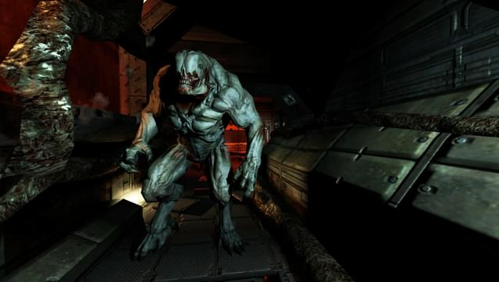

Doom 3's horror relies heavily on atmosphere. The claustrophobic corridors and flickering lights create a constant sense of dread. You never know when a demonic monstrosity will lunge from the shadows, and the jump scares are plentiful.

While the core gameplay loop involves shooting demons, Doom 3 also incorporates puzzle-solving elements and a more story-driven narrative than previous Doom titles.

The game was critically acclaimed for its innovative use of lighting and shadow, as well as its intense horror atmosphere. It was later remastered as Doom 3: BFG Edition in 2012, which included additional content and graphical improvements.